QUERY
CREATE TABLE Bank_40 (
bankcode VARCHAR(3) PRIMARY KEY,
bankname VARCHAR(50) NOT NULL,
headoffice VARCHAR(50),
branches INT CHECK (branches > 0)
);
INSERT INTO Bank_40 VALUES ('S01', 'SBI', 'Ernakulam', 120);
INSERT INTO Bank_40 VALUES ('H01', 'HDFC', 'Mumbai', 80);
INSERT INTO Bank_40 VALUES ('I01', 'ICICI', 'Kottayam', 60);
INSERT INTO Bank_40 VALUES ('P01', 'PNB', 'New Delhi', 40);
INSERT INTO Bank_40 VALUES ('F01', 'Federal', 'Ernakulam', 55);
SELECT * FROM Bank_40;
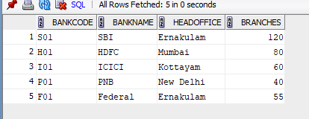
QUERY
CREATE TABLE Branch_40 (
branchid INT PRIMARY KEY,
branchname VARCHAR(50) DEFAULT 'New Delhi',
bankid VARCHAR(3),
FOREIGN KEY (bankid) REFERENCES Bank_40(bankcode)
);
INSERT INTO Branch_40 (branchid, branchname, bankid) VALUES (1, 'Kottayam', 'S01');
INSERT INTO Branch_40 (branchid, branchname, bankid) VALUES (2, 'Ernakulam', 'H01');
INSERT INTO Branch_40 (branchid, branchname, bankid) VALUES (3, 'Kottayam', 'I01');
INSERT INTO Branch_40 (branchid, bankid) VALUES (4, 'P01');
INSERT INTO Branch_40 (branchid, branchname, bankid) VALUES (5, 'Alappuzha', 'F01');
SELECT * FROM Branch_40;
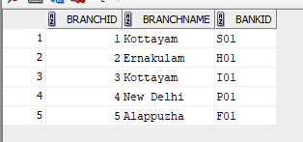
QUERY
CREATE VIEW bank_head_office AS
SELECT * FROM Bank_40
WHERE headoffice = 'Ernakulam';
SELECT * FROM BANK_HEAD_OFFICE;
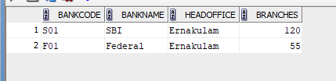
QUERY
CREATE VIEW bank_branch AS
SELECT b.*
FROM Bank_40 b
JOIN Branch_40 br ON b.bankcode = br.bankid
WHERE br.branchname = 'Kottayam';
SELECT * FROM BANK_40_BRANCH_40;
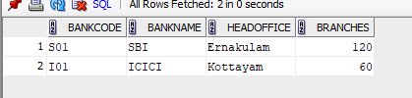

QUERY
CREATE VIEW bank_more_50 AS
SELECT * FROM Bank_40
WHERE branches > 50;
SELECT * FROM BANK_MORE_50;
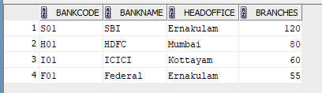
QUERY
CREATE VIEW bank_branch_details AS
SELECT b.bankname, br.branchname
FROM Bank_40 b
JOIN Branch_40 br ON b.bankcode = br.bankid;
SELECT * FROM BANK_BRANCH_DETAILS;
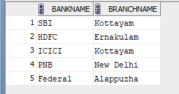
QUERY
CREATE VIEW bank_outside_ekm AS
SELECT * FROM Bank_40
WHERE headoffice <> 'Ernakulam';
SELECT * FROM BANK_OUTSIDE_EKM;
